Orators Report
on the 17th Degree
Knight of the East
and West
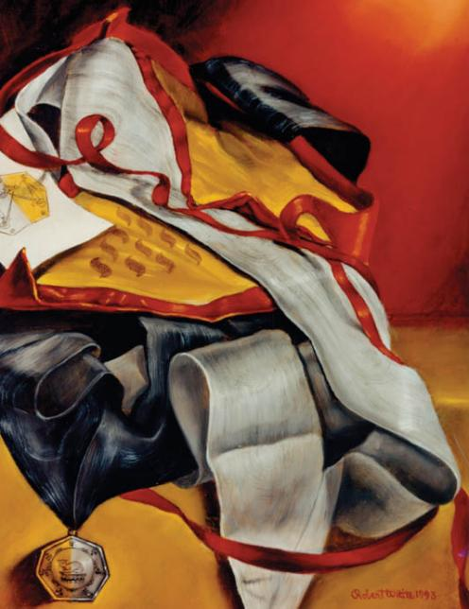
Sept 6, 2011

The apron of the 17th Degree is yellow and the trim of red. Both the apron body and the flap are triangular, symbol of the Deity.
Bremerton Valley of the Scottish Rite

The Legend: The 15th and 16th degrees deal with the Second Temple of Jerusalem, built by the Jews returning from the Babylonian captivity. The 17th deals with the last book of the New Testament, the Revelation to St. John the Evangelist.
The 15th Degree ritual tells the Biblical story of the Babylonian Captivity and the return of the captives to Jerusalem, whereon they built the Second Temple under the direction of King Cyrus. Continuing where the previous degree left off, the 16th degree, the Prince of Jerusalem, teaches the majesty of truth. The ritual tells of the difficulties in building the temple and how Prince Zerubbabel ordered the workmen to work with trowel in one hand and sword in the other. In the 17th degree, Knight of the East and West, the word, once lost, is lost once again. It instructs the Mason that the Third Temple is the Spiritual Temple within the heart of man and that it should be built and dedicated to God. The final degree of the Chapter of Rose Croix, the 18th - Knight Rose Croix, will be presented to the class. In the 18th degree the novice is still in search of truth and the lost word. He is taught that Faith, Hope and Charity are the three virtues which will guide him on his journey.
The Setting: The Audience Chamber of King Herod II is styled as the Chamber of the Council of the Preceptory in the shape of a heptagon.
The Ritual: The Master represents John the Baptist. It is believed by many that John the Baptist was a member of the Essenes, a small group of Jewish ascetics living near the Dead Sea. They practiced celibacy and thus maintained their group by admitting converts who were required to pass through a series of solemn initiations.
At the beginning of the reception, the candidate is received as a weary traveler who has crossed the desert and now wanders on the shore of the Dead Sea in darkness seeking light. The candidate is himself a symbol of the human soul, weary of the unprofitable speculation and empty logic of existing philosophies. The Dead Sea symbolizes the philosophies of Egypt and Greece which gave men little hope of eternal life.
Scholars believe purification by water and fire was an integral part of the Essenes initiation ceremonies. This degree symbolically enacts this ancient custom of baptizing the candidate with the spirit (water) and with fire. Once purified the candidate under goes a number of trials as God's soldier to war against fanaticism, intolerance, bigotry and all the evils which have made a hell of earth, which was created as a paradise. The last trial announces the last battle at the end of time. The world is ravaged by hail and fire, a volcanic eruption, a falling star, an eclipse, locusts and four demons slaying a third of mankind. The trumpet is heard seven times, the last trumpet announces that God and his Messiah have made the earth the Kingdom of God and He shall reign forever.
The Lecture: As the first of the Philosophical Degrees of the Scottish Rite, the lecture of the 17th teaches the same philosophical truths taught by the Essenes and preached by John the Baptist. It depends to some extent on how it is presented, but this can be one of the most powerful and profound of the Degrees of the Rite. The markedly Christian symbolism present in this degree may possibly cause some confusion or misunderstanding. Pike believed that the great truths come from the Zend-Avesta of the Persians, the Vedas of the Hindus, the writings of Plato and Pythagoras, from the ancient countries Phoenicia, Syria, Greece and Egypt as well as from the Holy Books of the Jews. Masonry gleaned the truth from the error in these ancient doctrines and continues to pass it on. They are very simple and sublime lessons: God is one, immutable, unchangeable, infinitely just and good; light will finally overcome darkness, good conquer evil, and truth be over error.
The last trial illustrates that fidelity and courage are required of a Knight of the East and West who is always ready to lay his life upon the altar of God, of friendship, of his country, or of the human race.
The candidate is invested with the collar, apron and jewel of the degree and their symbolism is explained.

THE MORAL TEACHING: In this degree, Masonry says only one thing - differences in religions should not matter, and these differences should not hinder people to live together in peace if all people gather sincerely around the belief and concept of the Great Architect of the Universe. It is sufficient only to keep one's heart pure, to believe in God, and to respect the religious feelings and ideas of others. In this way, people who meet, respect and love one another will not find it difficult to understand that no one is lying, that truth prevails in people's words and deeds.
DUTIES:
- To work, to reflect and to pray.
- To hope, to trust and to believe.
- To teach the truths that are hidden in allegories
- and concealed by the symbols of Freemasonry.
FOR REFLECTION: Can Masonry teach religion without being a religion?
IMPORTANT SYMBOLS:
East, West, John the Baptist, number 7.
The body of the apron is decorated with the Tetractys, formed of 10 Yuds. They are symbolic of the ten manifestations of God found on the Tree of Life of the Kabbalah and, thus, symbolic of God's action in the creation and maintenance of the universe.
There are two cordons, one of black and one of white, which are worn from shoulder to hip. Since change or transformation is a major theme of the 17°, precursor to the 18° as its central character, John the Baptist, was precursor to the central (if unseen) character of the 18°, Jesus of Nazareth, the crossed cordons may serve as a symbolic alert to the theme of transformation—in this case the transformation of vital but unrefined spiritual power into the focused spirituality of the Law of Love.

Adapted from the Spanish version of Rex R. Hutchen’s book A Bridge to Light

